**Superset ID: 6394725**

**ReactJS-HOL**

**HANDS ON-13:**

Create a React App named “bloggerapp” in with 3 components.

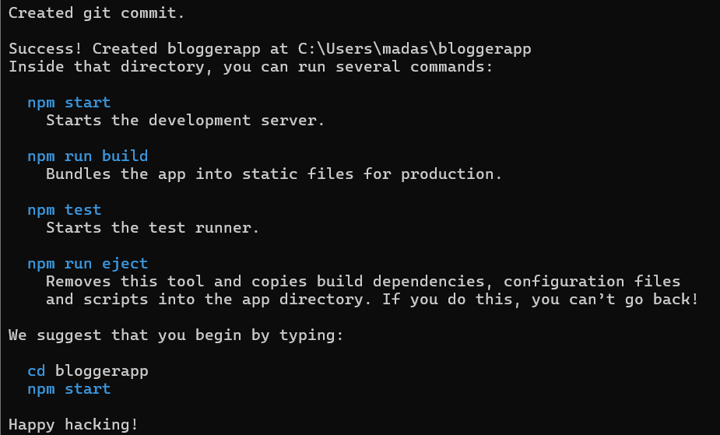

1. Book Details
2. Blog Details
3. Course Details

Implement this with as many ways possible of Conditional Rendering.

